Abstract Title in APA Style Title Case

Firstname Lastname1, Firstname Middlename Lastname2, Firstname M. Lastname1

*1Department, Institution, City, State/Province, Country*

*2Department, Institution, City, Country*

This document provides an example of the layout and style for the abstract submissions for the *Conference MIDEM*.

Abstracts must be in English and should contain new scientific work. The total length should not be more than two A4 pages (1 page for the Abstract Summary + one explanatory page). The Abstract should cover the aim of the work, scientific innovation and (preliminary) results.

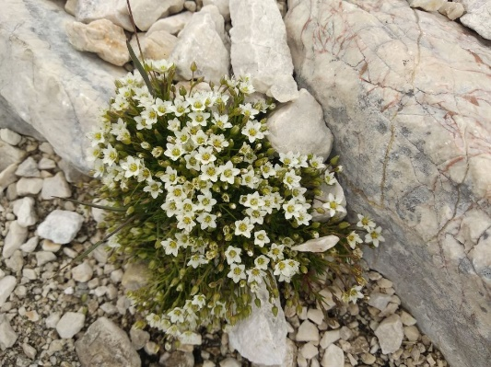

Figure: Images must have a resolution of at least 300 dpi.

# References

[1] J. K. Author, “Name of the Paper,” *Abbrev. Title Period.*, vol. 25, no. 3, pp. 99–108, 2020, https://doi.org/10.33180/InfMIDEM2019.xyz.

[2] J. K. Author, *Book Title*, 1st ed. London, 2018.